This is a test document before changes

TASK 02

Tihis is a test task to be performed

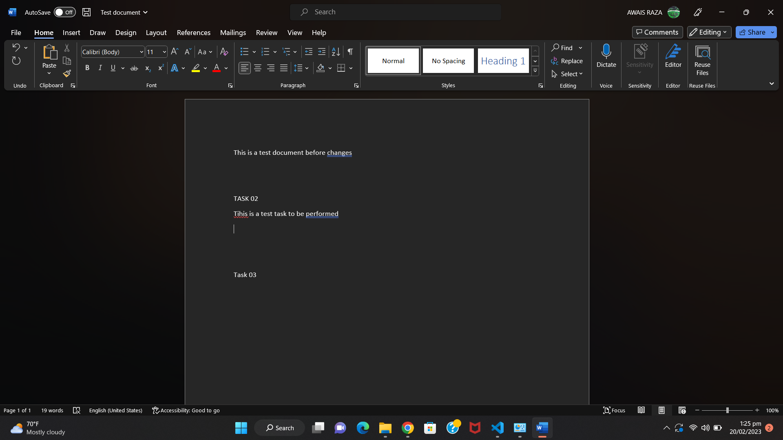

Task 03

Hello with the new task of the people of the world have to be followed by the almount of the previou have to the

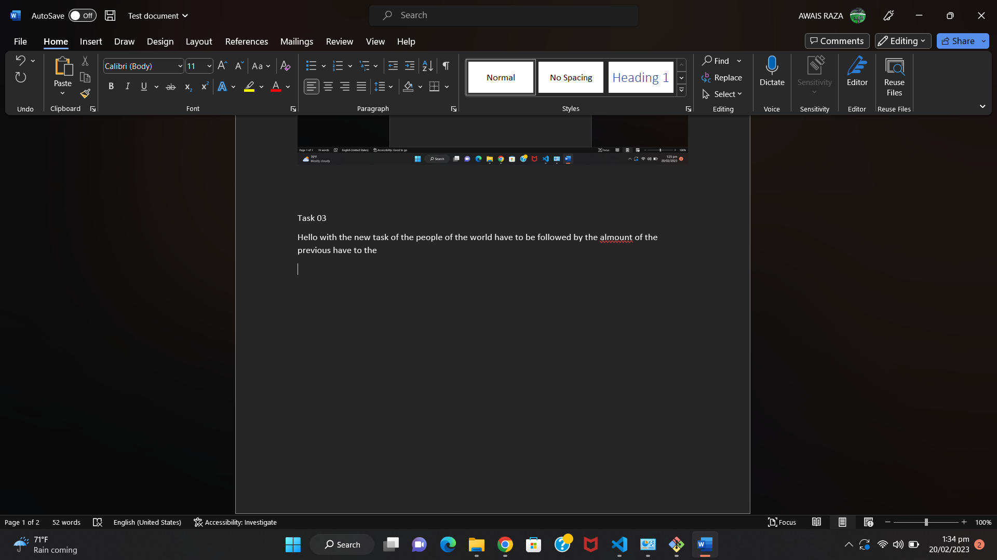

Task 04

This is the opener of the match

